GLOW LOGICS DIGITAL MARKETING A PROJECT ON

SEO AUDIT OF A WEBSITE
A Local SEO Case Study of Murugan Idli Shop
Bachelor of Science in AI&DS
Ⅱ YEAR B.Sc – (AI&DS)
Submitted by,
S.ARAVINDH (Reg.No:12225050010)
DEPARTMENT OF SCIENCE

DHANALAKSHMI SRINIVASAN UNIVERSITY SCHOOL OF ARTS & SCIENCE SAMAYAPURAM,TRICHY- 621112.
SEPTEMBER- 2026

TABLE OF CONTENTS
Project structure

No. | Section | Page
1 | Introduction | 1
2 | Objective & Scope | 2
3 | Selected local Business  Website | 3
4 | Customer Search  Journey | 4
5 | Keyword Analysis | 5
6 | On-Page SEO Audit | 6
7 | Technical SEO Audit | 7
8 | Page Speed Analysis | 8
9 | Backlink Analysis | 9
10 | Local SEO Analysis | 10
11 | SEO Tools | 11
12 | Suggested  Improvements | 12
13 | 30-Day SEO Action  Plan | 13
14 | Conclusion and  References | 14

SEO AUDIT OF A WEBSITE – FLOW CHART

SEO Audit of a Website
Complete analysis of a website to improve search visibility, traffic and online performance
↓

Introduction
Understanding SEO, its importance and the purpose of conducting an SEO audit
↓

Selected Local Business Website
Introduction to the selected local business website – Murugan Idli Shop
↓

Website Analysis
Examining website structure, content, navigation and overall user experience
↓

Keyword Analysis
Identifying relevant keywords and evaluating their use in website content
↓

On-Page SEO Analysis
Checking title tags, meta descriptions, headings, URLs, images and content
↓

Technical SEO Analysis
Evaluating mobile-friendliness, indexing, crawlability and technical performance
↓

Page Speed & Backlink Analysis
Checking website loading speed and analysing backlink quality and quantity
↓

SEO Tools Used
Using Google Search Console, PageSpeed Insights, SEMrush and Ubersuggest for analysis
↓

SEO Problems Identified
Identifying the major SEO issues affecting website visibility and performance
↓

SEO Improvement Suggestions
Providing practical recommendations to improve rankings, traffic and user experience
↓

SEO Action Plan
Creating a step-by-step plan for implementing the recommended SEO improvements
↓

Expected Outcomes
Expected improvements in organic traffic, search visibility, rankings and online reach
↓

Conclusion
Summary of the SEO audit findings and the importance of continuous SEO improvement
↓

References
Sources, websites and SEO tools used for preparing the project

Introduction

Meaning of SEO

Search Engine Optimization (SEO) is the process of improving a website so that search engines can crawl, understand, index and display its pages for relevant searches. SEO combines technical improvements, useful content, keyword research, website structure, user experience, links and local business signals.

Importance of SEO for Local Businesses
Local businesses depend strongly on customers who search for products or services in a particular city, neighbourhood or nearby area. A restaurant can receive discovery opportunities when people search for terms such as “South Indian restaurant in Chennai”, “idli near me” or “dosa restaurant near T Nagar”.
Local SEO connects online search behaviour with offline business visits. It helps potential customers find location, opening hours, menu, phone number, directions and reviews.

Purpose of the Project
This project demonstrates how an SEO audit can be conducted for a local business website. Murugan Idli Shop is used as the case study because it is a South Indian food brand with Chennai outlets and a dedicated website.

Objectives and Scope

Objectives
    - Understand the SEO opportunities of a local business website.
    - Identify relevant local keywords and search intentions.
    - Examine important on-page SEO factors.
    - Understand page-speed and technical SEO requirements.
    - Review backlink and local citation opportunities.
    - Identify local SEO improvement areas.
    - Recommend a practical action plan for improving organic visibility.

Scope

Audit Area | Scope
Keyword research | Local, branded, product/service and long-tail keywords
On-page SEO | Titles, meta descriptions, headings, URLs, content, images and links
Technical SEO | Indexing, sitemap, robots.txt, HTTPS, canonical tags and structured data
Page speed | Mobile/desktop performance and Core Web Vitals
Backlinks | Referring domains, relevance, quality and local citations
Local SEO | Business information, location pages, reviews and local search signals
Measurement | Search Console and SEO research tools

This is an academic audit framework. Current live metrics such as PageSpeed scores and backlink counts should be entered directly from the relevant tools on the submission date.

Selected Local Business Website

Business Profile

Particular | Details
Business name | Murugan Idli Shop
Industry | Food & Restaurant
Cuisine | South Indian
Primary market | Tamil Nadu / Chennai
Website | https://muruganidlishop.com/
SEO focus | Local restaurant discovery
Main customer actions | Visit outlet, view menu, contact, locate outlet

Reason for Selection
A restaurant is strongly connected to location-based search intent. Customers frequently search for food based on cuisine, dish, neighbourhood and proximity. A business with multiple physical outlets also provides a useful example for studying location pages, local keywords and business information.

Target Audience
    - Chennai residents searching for South Indian food.
    - Customers searching for idli, dosa, pongal and vegetarian breakfast.
    - People searching for restaurants near a specific neighbourhood.
    - Tourists and visitors interested in traditional Tamil cuisine.
    - Existing customers looking for menu, outlet, contact or directions.

Customer Search Journey

Awareness Stage
Users may not know the brand. Searches may include “South Indian restaurant Chennai”, “best breakfast Chennai” or “idli restaurant near me”. Useful local content can introduce the business.

Consideration Stage
Users compare restaurants, menus, locations, reviews and convenience. The website should provide useful information without forcing visitors to search elsewhere.

Purchase / Visit Stage
For a restaurant, conversion can be a physical visit, phone call, online order or direction request.
Clear location details, opening hours, menu information and mobile actions are important.

Retention Stage
After a visit, customers may return, leave a review or search for another outlet. Helpful updates, reviews and useful content can support repeat discovery.

SEO Implication
The website should not target only one keyword. It should contain a structured set of pages supporting different search intents throughout the customer journey.

Keyword Analysis
Keyword research identifies phrases potential customers use in search engines. For this project, keywords are grouped into branded, category, product, local and long-tail terms.

Type | Examples | Purpose
Branded | Murugan Idli Shop Chennai | Capture brand-aware users
Category | South Indian restaurant Chennai | Reach category searches
Product | idli restaurant Chennai; dosa restaurant Chennai | Reach dish-specific searches
Local | South Indian restaurant T Nagar | Reach neighbourhood intent
Near-me | idli near me | Capture proximity searches
Long-tail | South Indian breakfast near T Nagar | Target specific intent
Navigational | Murugan Idli Shop menu | Help users find a page

Keyword Selection Guidelines
    - Choose terms matching actual products/services.
    - Include location modifiers naturally.
    - Use related words rather than repeating one keyword.
    - Prioritize search intent over keyword stuffing.
    - Use Search Console to identify real queries generating impressions.
    - Use SEMrush and Ubersuggest to research volume, competition and variations.

Example Keyword Map

Page | Primary Topic | Supporting Terms
Homepage | South Indian restaurant Chennai | idli, dosa, vegetarian food
Menu | Murugan Idli Shop menu | idli, dosa, pongal, chutney
Location page | Restaurant in [area] | nearby breakfast, directions
Blog/Guide | South Indian breakfast | traditional breakfast, Chennai food

On-Page SEO Audit
On-page SEO includes elements controlled within the website. These elements should help search engines and users understand the purpose of each page.

Element | Audit Check | Suggested Improvement
Title tag | Unique and location relevant | Use business/service/location naturally
Meta description | Unique summary and CTA | Write useful descriptions for major pages
H1 | Clear main topic | Use a descriptive primary heading
Subheadings | Logical hierarchy | Use H2/H3 sections
URL | Short and readable | Use descriptive page slugs
Images | ALT text and size | Compress and describe meaningful images
Internal links | Relevant pages connected | Connect menu, locations and contact
Content | Useful and original | Avoid thin/duplicate location content
Mobile design | Easy navigation | Optimize for mobile users
Schema | Business information markup | Use suitable  Restaurant/LocalBusiness structured data

Title and Meta Description
A page title should communicate the subject clearly. A location page could use a format such as “South Indian Restaurant in [Location] | Murugan Idli Shop”. Meta descriptions should explain the page and encourage an appropriate click without keyword stuffing.

Content Quality
Restaurant pages should provide practical information such as cuisine, menu highlights, outlet details, directions, opening hours and FAQs. Location pages should contain genuinely useful information rather than identical copied text.

Technical SEO Audit

Crawlability and Indexing
Check robots.txt, XML sitemap, HTTP status codes, redirects, canonical tags and whether important pages are indexable.

HTTPS and Security
The website should use HTTPS consistently as a baseline for secure browsing and user trust.

Mobile Friendliness
Many local searches happen on mobile. Navigation, buttons, menu information, contact details and locations should work comfortably on small screens.

Structured Data
Appropriate Restaurant or LocalBusiness structured data can help search engines understand business information. It should be validated after implementation.

Canonical URLs
Canonical tags can help identify the preferred version of pages where similar URLs or duplicate versions exist.

XML Sitemap
The sitemap should contain important canonical URLs and be submitted through Google Search Console.

Page Speed Analysis

Importance
A slow website can create friction for users, especially on mobile connections. Page speed analysis identifies technical resources that make pages heavier or slower to become interactive.

Google PageSpeed Insights Procedure
- Open Google PageSpeed Insights.
- Enter the website URL.
- Run a mobile test.
- Run a desktop test.
- Record Performance, Accessibility, Best Practices and SEO results.
- Review Core Web Vitals: LCP, INP and CLS.
- Read diagnostics for images, scripts, CSS and caching.
- Implement improvements and repeat the test.

Common Speed Improvements
    - Compress and resize large images.
    - Use modern image formats where suitable.
    - Reduce unnecessary JavaScript and CSS.
    - Minimize render-blocking resources.
    - Use caching where appropriate.
    - Lazy-load non-critical images.
    - Reduce unnecessary third-party scripts.
Verification note: This report does not invent a current PageSpeed score. The actual score should be entered from the PageSpeed Insights test performed on the submission date.

Backlink Analysis

Meaning of Backlinks
A backlink is a link from another website to the business website. Links can help discovery and are one of many signals considered by search engines.

Relevant Backlink Sources
    - Local business directories with genuine relevance.
    - Food and restaurant publications.
    - Local news and community websites.
    - Tourism and city guides.
    - Supplier or business partner websites where appropriate.
    - Independent food bloggers and creators.

Backlink Audit Procedure
Export referring domains using SEMrush or Ubersuggest. Check domain relevance and quality.
Identify lost or broken backlinks. Review anchor-text patterns.
Identify local citation gaps.
Create a plan for earning relevant links.

What to Avoid
The objective is not to obtain the largest possible number of links. Large quantities of unrelated or manipulative links can create quality risks. Relevance, authenticity and usefulness should guide link-building.

Local SEO Analysis
Local SEO helps businesses appear when people search for services in a particular area. For a restaurant with multiple outlets, local information should be accurate and easy to find.

Google Business Profile
    - Maintain an accurate business name and category.
    - Verify address and phone information.
    - Keep opening hours updated.
    - Add current photographs.
    - Provide relevant business information.
    - Monitor and respond professionally to customer reviews.

Location Pages
Each important outlet can have a useful location page containing the outlet name, address, opening hours, directions, local landmarks, menu information and phone number.

NAP Consistency
NAP means Name, Address and Phone number. Consistency across the website and reputable local directories helps reduce confusion for customers and search engines.

Reviews
Customer reviews can influence how people evaluate local businesses. The business should encourage genuine reviews without creating fake or incentivized feedback. Responses should be professional and helpful.

SEO Tools

Tool | Main Use | Data to Collect
Google Search Console | Organic search and indexing | Queries, clicks, impressions, CTR, position, indexing
Google PageSpeed Insights | Performance and Core Web Vitals | Performance, LCP, INP, CLS, diagnostics
SEMrush (Free Trial) | Keywords, competitors, backlinks, audit | Keyword ideas, referring domains, technical issues
Ubersuggest | Keyword and backlink research | Keyword ideas, SEO difficulty, backlink information

Google Search Console
Search Console provides first-party information about how Google search interacts with a verified website. It can identify queries, pages, clicks, impressions and indexing issues.

Google PageSpeed Insights
PageSpeed Insights provides mobile and desktop performance diagnostics and reports Core Web Vitals and other opportunities.

SEMrush
SEMrush can support keyword research, competitor research, backlink analysis and technical site audits. A free trial/account may limit reports or results.

Ubersuggest
Ubersuggest provides keyword ideas and SEO research features. Exact limits depend on the current account and plan.

Suggested Improvements
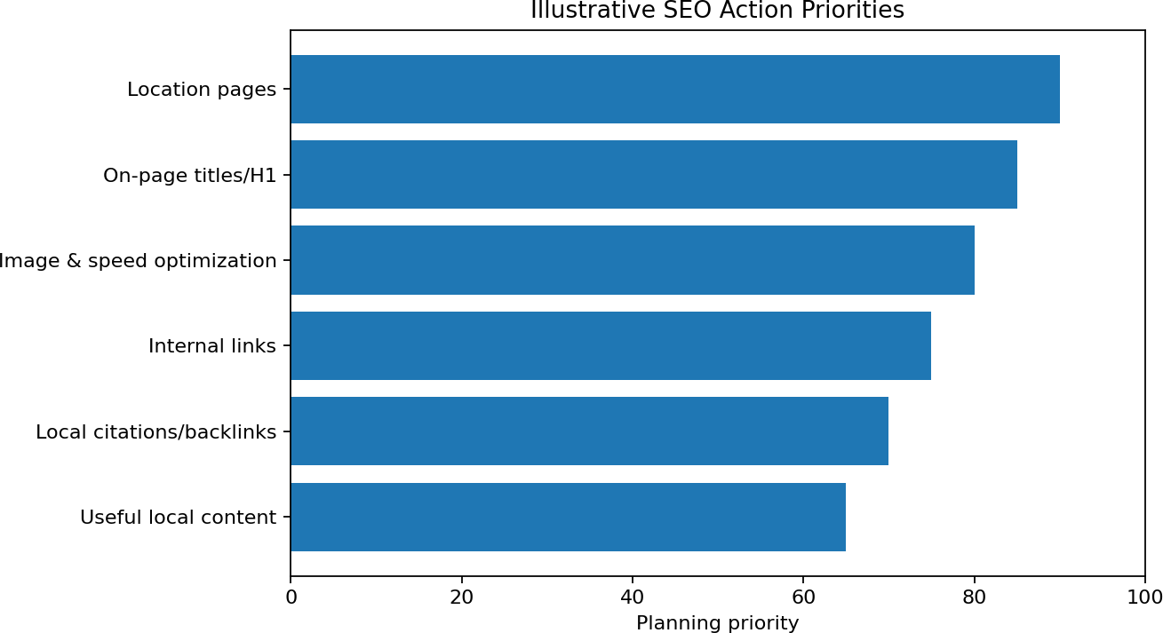

Priority | Recommendation | Expected Benefit
High | Improve page titles, H1s and meta descriptions | Clearer relevance and click opportunity
High | Create/strengthen location pages | Better local search targeting
High | Optimize images and resources | Improved mobile experience
High | Improve internal linking | Better discovery and structure
Medium | Strengthen local citations | Consistent business information
Medium | Earn relevant local backlinks | Potential authority/referral traffic
Medium | Publish useful Chennai food content | Broader long-tail visibility
Medium | Add/validate structured data | Better machine-readable information
Ongoing | Monitor Search Console and PageSpeed | Measure and refine

Content Recommendations
    - South Indian breakfast guide for Chennai.
    - Idli and dosa menu guide.
    - Guide to vegetarian breakfast options.
    - Neighbourhood-specific restaurant information.
    - FAQs about menu, timings and outlets.
    - Helpful content about traditional South Indian dishes.

30-Day SEO Action Plan

Period | Activities | Output
Days 1–7 | Technical check; Search Console baseline; PageSpeed tests; keyword research | Baseline report
Days 8–14 | Titles, meta descriptions, headings, ALT text and internal links | On-page improvements
Days 15–21 | Location pages, local information, citations and useful content | Local SEO improvements
Days 22–30 | Backlink review, performance retest and Search Console review | Before/after comparison

Key Performance Indicators
    - Organic clicks from Google Search.
    - Organic impressions.
    - Click-through rate.
    - Average position for selected keywords.
    - Number of indexed important pages.
    - Core Web Vitals status.
    - Organic traffic to location pages.
    - Relevant referring domains.
    - Calls, direction requests or other measurable local actions.

Reporting Format
The final report should contain a baseline date, tool used, measured value, recommended action, implementation date and follow-up value. This makes the project measurable instead of relying only on general SEO advice.

Conclusion and References

Conclusion
SEO is an ongoing process rather than a one-time website activity. For a local restaurant, the most useful approach is to combine technical accessibility, relevant local keywords, strong on-page structure, useful content, fast mobile performance, accurate local business information and relevant backlinks.
For the Murugan Idli Shop case study, the website should be evaluated around the real search needs of Chennai customers: finding a suitable restaurant, discovering a nearby outlet, checking the menu, obtaining directions and deciding whether to visit. The recommendations in this project provide a practical roadmap for improving those discovery paths.
The next stage is measurement. Search Console, PageSpeed Insights, SEMrush and Ubersuggest should be used to record actual current metrics, implement improvements and compare results after a defined period. This prevents unsupported assumptions and creates a repeatable SEO audit process.

References
    - Murugan Idli Shop official website: https://muruganidlishop.com/
    - Google Search Console: https://search.google.com/search-console/
    - Google PageSpeed Insights: https://pagespeed.web.dev/
    - SEMrush: https://www.semrush.com/
    - Ubersuggest: https://neilpatel.com/ubersuggest/
    - Google Search Central: https://developers.google.com/search/
Project Note: Replace any illustrative/planning information with live tool results on the submission date.

